SECTION 1: Hands-On Demonstration

Part 1. Group Policy

1. the updated policy settings for the new PasswordGPO (screen capture):

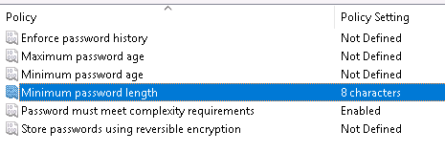

Part 2. User and Group Administration

1. members of the Managers group (screen capture):

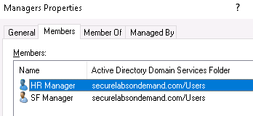

1. members of the HumanResources group (screen capture):  
     
   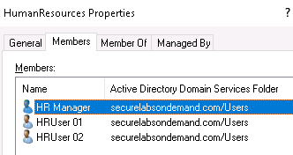
2. members of the ShopFloor group (screen capture):

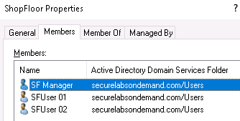

Part 3. Resource Management

1. updated share permissions for the MGRfiles folder (screen capture):

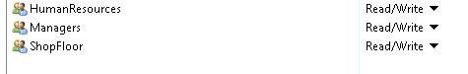

1. updated share permissions for the HRfiles folder (screen capture):



3. updated share permissions for the SFfiles folder (screen capture):  
  


Part 4. Practical Application

1. accesstest text file for HRUser01 (screen capture):

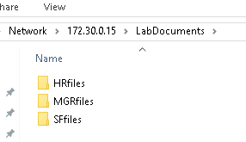

1. accesstest text file for SFManager (screen capture):  
     
   

SECTION 2: Applied Learning

Part 1. User and Group Administration

1. the two new users within the Contractors OU (screen capture):

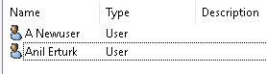

Part 2. Group Policy

1. the new Password Policy for the yourname_PasswordGPO (screen capture):  
     
   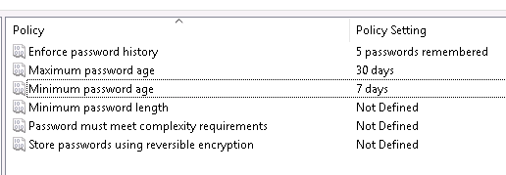
2. the new Account Lockout Policy for the yourname_PasswordGPO (screen capture):  
     
   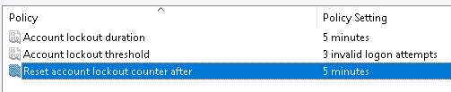

Part 3. Resource Management

1. the contents of the CoreFiles directory (screen capture):

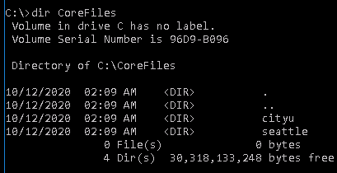

1. the updated Security permissions for the *yourtown* directory (screen capture):

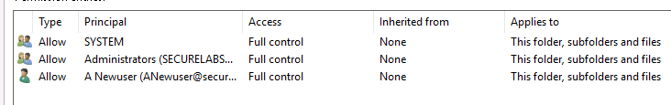

Part 4. Practical Application

1. the result of Part 4, Step 3 (screen capture):

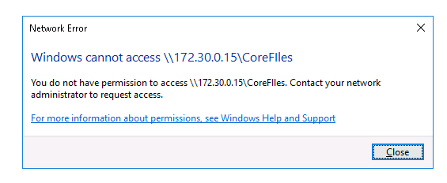

SECTION 3: Observation Summary

As we can see in the topology, we have a client and we have a server. We connect to the server using RDP and create folders, create users and user groups, and we share these folders with certain users. And then we go back to the client and we remotely try to use a certain user by supplying it’s username and password to the server. And then we try to access the folders in the server remotely by specifying the IP and the path.